yum update -y

yum update

cd /

yum update

yum update

YumRepo Error: All mirror URLs are not using ftp, http[s] or file.baseurl=http://vault.centos.org/$releasever/centosplus/$basearch/

baseurl=http://vault.centos.org/$releasever/centosplus/$basearch/

yum update

cd var/

ls

cd ..

cd /etc/yum.repos.d/

cp CentOS-Base.repo CentOS-Base.repo.old

vi CentOS-Base.repo

ll

rm -rf CentOS-Base.repo

vi Centos-Base.repo

yum clean all

yum update

cd

**CW-AGENT CENTOS**

**Create IAM role and attach  CloudWatchAgentServerRole** Policy in IAM role.

wget https://s3.amazonaws.com/amazoncloudwatch-agent/linux/amd64/latest/AmazonCloudWatchAgent.zip

yum install wget unzip -y

wget https://s3.amazonaws.com/amazoncloudwatch-agent/linux/amd64/latest/AmazonCloudWatchAgent.zip

unzip AmazonCloudWatchAgent.zip

sudo ./install.sh

sudo /opt/aws/amazon-cloudwatch-agent/bin/amazon-cloudwatch-agent-config-wizard

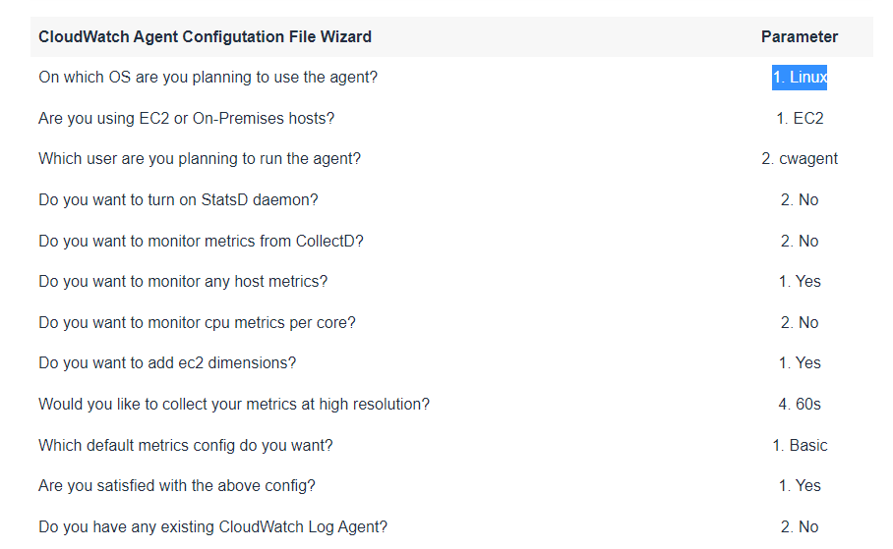



sudo /opt/aws/amazon-cloudwatch-agent/bin/amazon-cloudwatch-agent-ctl -a fetch-config -m ec2 -c file:/opt/aws/amazon-cloudwatch-agent/bin/config.json –s

It may take up to 5 minutes for the metrics to become available, go back to the **Amazon CloudWatch** console page, under the **Metrics** session to validate that you are getting Memory information.

Click **CWAgent**: